Natural Resource Use
http://www.bbc.com/earth/story/20160113-12-nests-you-wont-believe-were-made-by-insects
http://www.bbc.com/earth/story/20150307-the-16-most-amazing-bird-nests
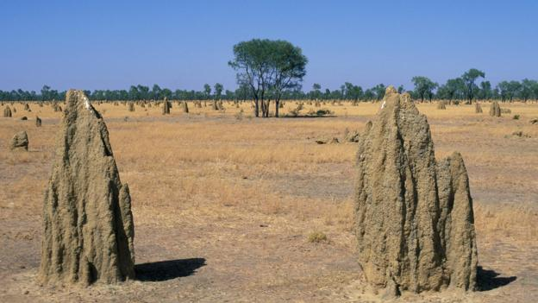
Spinifex termite (Nasutitermes triodiae)
Popularly known as the cathedral termite, this species is found in the spinifex or hummock grasslands of Australia. It builds huge cathedral-like mound nests out of sand and clay.

Millions of grass-eating termites can thrive in a single mound, a massive structure at times weighing over 10 metric tons. Mounds vary in shape from colony to colony: they may have blunt or pointed tops, and a smooth or bulbous appearance.
What resources does this organism use from its environment?

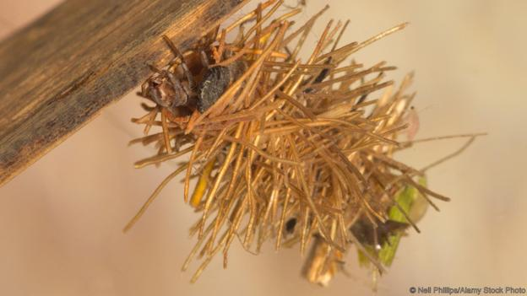
Caddisfly (Limnephilus rhombicus)
Found in stagnant or slow-running waters with dense underwater vegetation in North America and Europe, the larvae of this caddisfly build themselves a special casing to evade predators.

A larva will create a thick tubular case out of twigs and aquatic plant roots, and embed it with snail shells. It cements these raw materials using silk it spins to form a hard, protective covering.
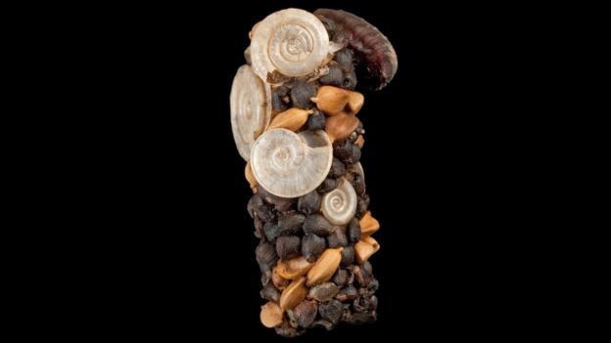
The larva can drag this covering around with its body protruding out. This portable home is not only a safe retreat from predators but also helps the larva survive shortages of oxygen.

When it is time to pupate, the larva plugs the ends of the case and breathes through small holes in it.
What resources does this organism use from its environment?

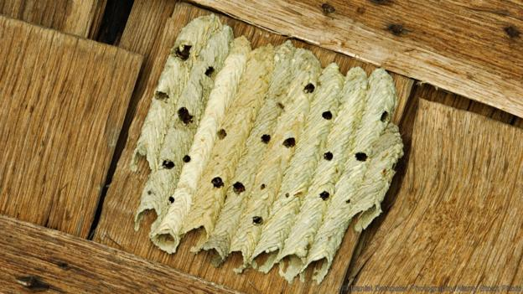
Organ-pipe mud-dauber (Trypoxylon politum)
Mud-dauber wasps nest on cliffs, walls and bridges with easy access to mud. They make their nests on smooth, vertical surfaces sheltered from sunlight and rain.

To make one, the female wasp shapes mud into a pipe and partitions it into a few "brood chambers". There she will lay eggs and stockpile several small spiders or a few large ones for her young to eat.

Before collecting mud, a female checks its consistency with her mouth; she tests quite a few sources before settling on one. Once she is satisfied, she lunges with her jaws spread out and scoops some mud. Then passing it on to her front legs, she again lunges and scoops some more, and finally flies away with the load.

With every load of mud brought thereafter, she makes a strip starting in the middle, working it downwards to meet the surface. A strip on one side is alternated with that on the other. The resulting nest has an inverted V-shaped striped appearance on the outside; on the inside it is made smooth.

A male guards the nest while the female builds it, and when she is away collecting spider-food for their unborn children.
What resources does this organism use from its environment?

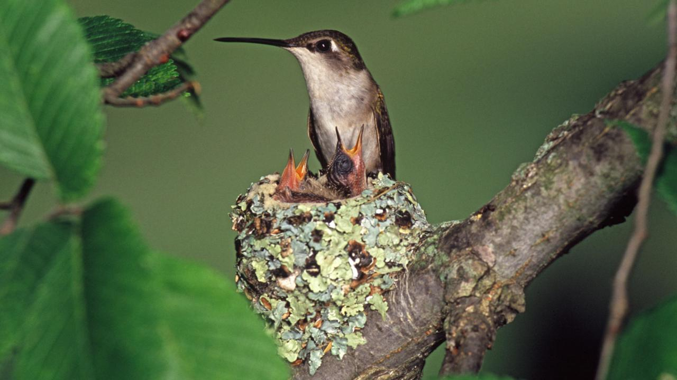
Ruby-throated Hummingbird (Archilochus colubris)
These hummingbirds build a tiny, knot-like structure attached to a tree branch with spider silk. The nest structure is crafted from bark, leaf strands and silk fibres, which make it strong and stretchable. It is decorated on the outside with lichen for camouflage and lined on the inside with hair or feathers for insulation.

What resources does this organism use from its environment?

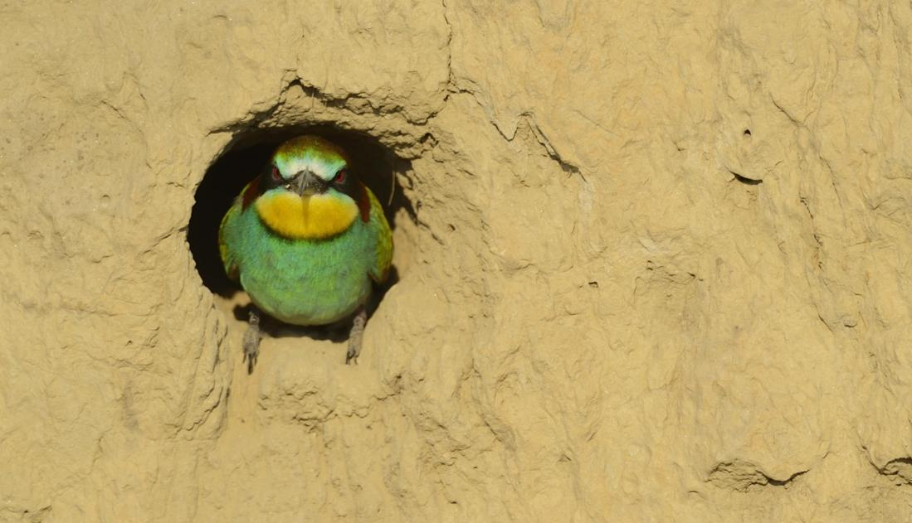
European Bee Eater (Merops apiaster)

This bird digs a horizontal cavity into the sand on a river embankment. To build a nest, a bee eater hovers over a suitable site, drills a hole with its bill, alights and then excavates a burrow using its feet to scoop out sand. The bird chooses the nest site with the utmost care, as the soil has to be soft, yet safe from caving in.
What resources does this organism use from its environment?

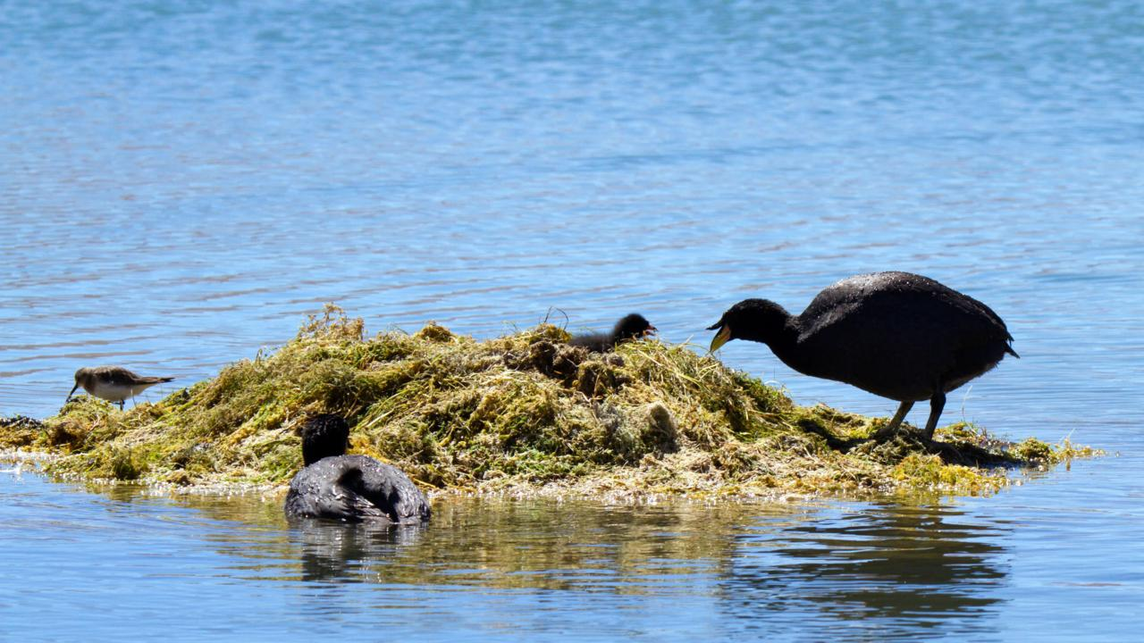
Horned Coot (Fulica cornuta)

Pairs of these birds build their nests in shallow waters, using pebbles carried from the shore in their beaks. The result is an island of pebbles weighing about 1.5 tonnes, topped with vegetation. The mound keeps the nest safe from water currents.
What resources does this organism use from its environment?

Choose a species from the readings:

What are some potential problems to their environment if the population grew too large?

What resources do you use from the environment?

